Screenshot of Sheet 1 (2018) results:

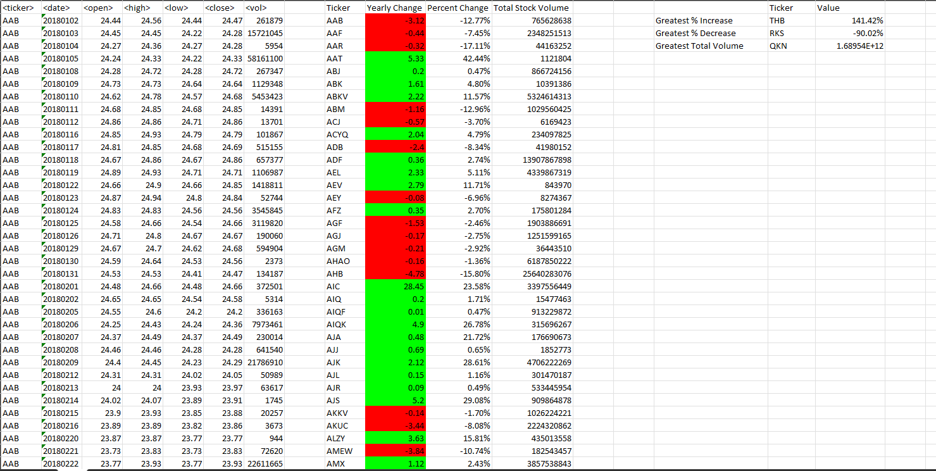

Screenshot of Sheet 2 (2019) results:

Screenshot of Sheet 3 (2020) results:

